Deer Chase Elementary  Andrea Williams | 
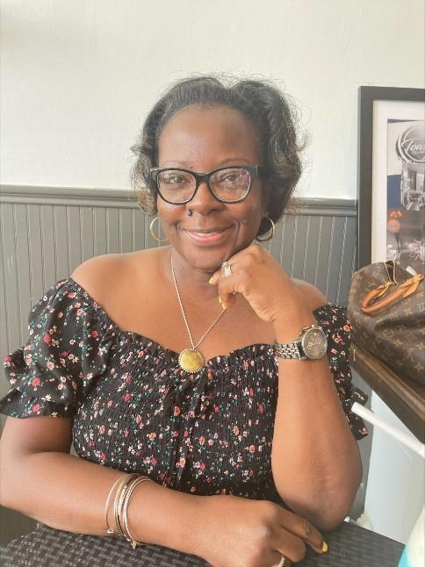  A Little About Me  I am originally from Mississippi. My loving husband, an Augusta Native, and I have a blended family of seven and an amazing grandson.  Contact Me  Email: willian4@boe.richmond.k12.ga.us  ClassDojo  Phone: (706)772-6240 | Greetings TrailBlazers!  I am super excited about my move to Deer Chase Elementary for the 2023-24 School Year. More importantly, I am looking forward to teaming up with you and your child as we journey through a rewarding year of teaching, learning and development (all with a twist of fun).  Teaching is a huge responsibility and I will do my best to create and foster a classroom environment that is both safe, engaging and motivating.  My aim is to identify and enhance the unique, individual potential for academic achievement for each of my students.  My expectation of each student is that they always strive to achieve their best.  I believe that parent-teacher relationships are necessary for maximum academic success.  Favorites Things  - Color(s): Green and Purple  - Candy: Reese’s  - Food: Watermelon  - Drink: Pepsi  - Hobby: Spending time with Family,  Dancing, Skating and Traveling  - Things: Colored Pens  - Sports Team: 49ers

